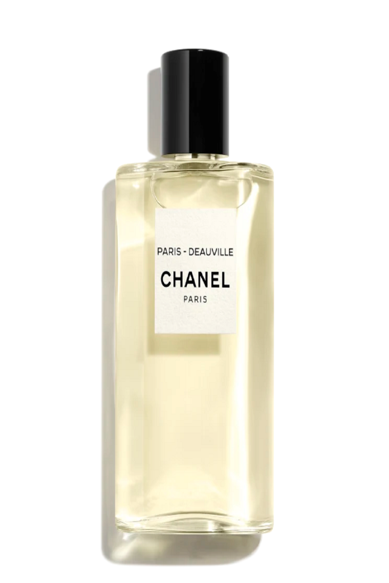

CK ONE

PKR 15,000

Tax Included.

100 mL

IN STOCK

Product Details:

Purity. Unity. Sensuality. The revolutionary first CK fragrance is designed for men and women to share. Clean and contemporary with a refreshing green tea signature throughout, it is intended to be used lavishly.

Top notes: bergamot, cardamom, pineapple, papaya Mid notes: jasmine, violet, rose, nutmeg End notes: musk, amber